Is there someone you would like to honor for
their service to our country or community?
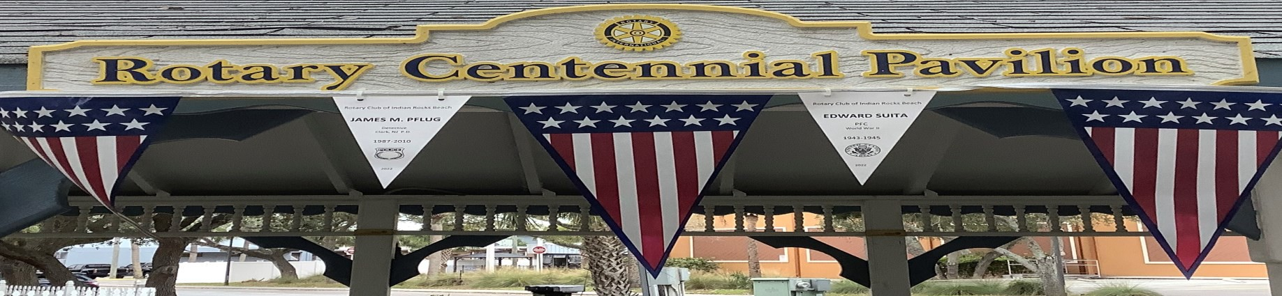

FLAGS FOR SERVICE
The Rotary Club of Indian Rocks Beach looks to honor those who are or have served our nation and communities. From Memorial Day (5/30/22) until Flag Day (6/14/22), hundreds of
U.S. Flags will be displayed in Chic-A-Si Park on Indian Rocks Beach to show appreciation for the sacrifices and dedication of current and former members of our Armed Forces and First Responders.
Honor your family or friends who are serving or have served our country and community. Sponsor a flag and create a custom banner for those you wish to honor. Your banner will proudly display the name, branch, rank, place of service and service time of your particular hero. After our Flag Day celebration, you will be able to collect your banner as well as one of the flags displayed.
Proceeds from the project will be used to support various programs in our community and beyond. A portion of this year’s proceeds will support local charities Operation Military Matters and Remember Me NFP.

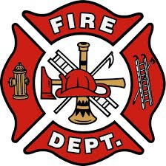
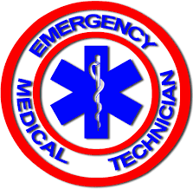
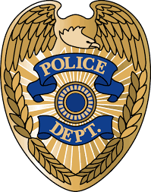
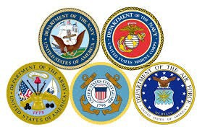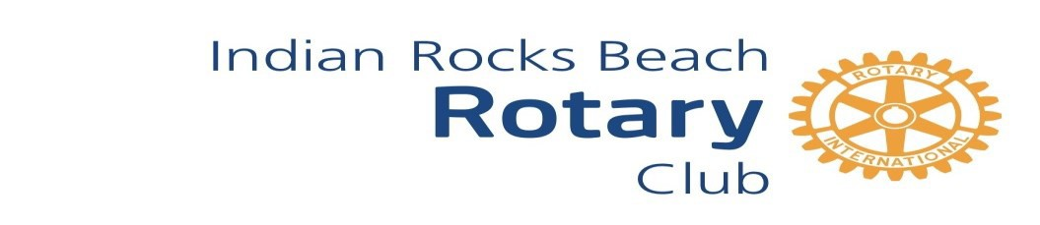Please visit IndianRocksRotary.Org to create a custom banner for your honoree for just $35.00. Order before May 7, 2022.

